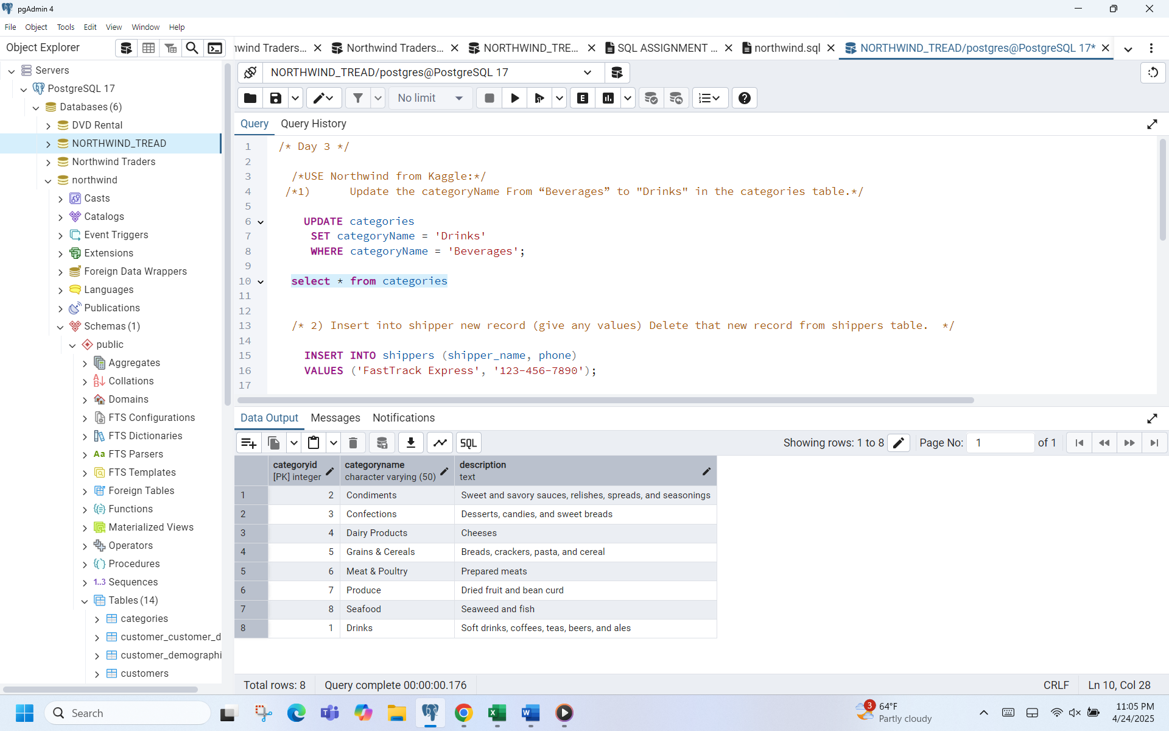

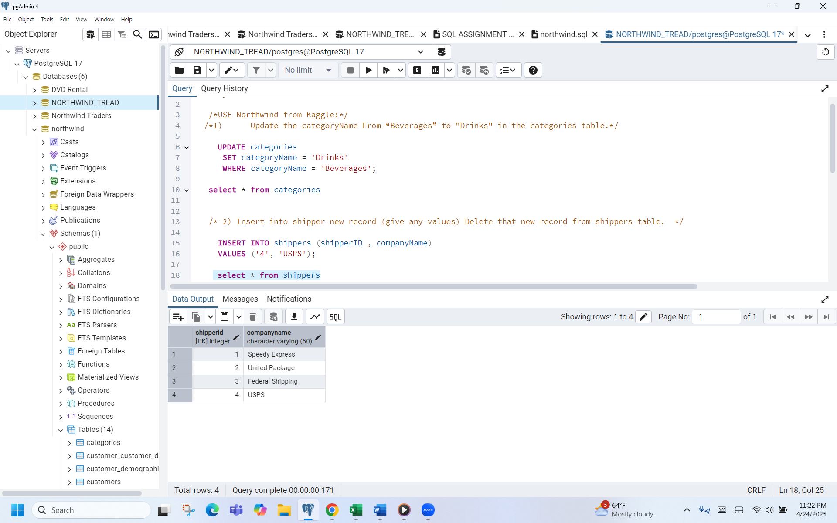

7.

